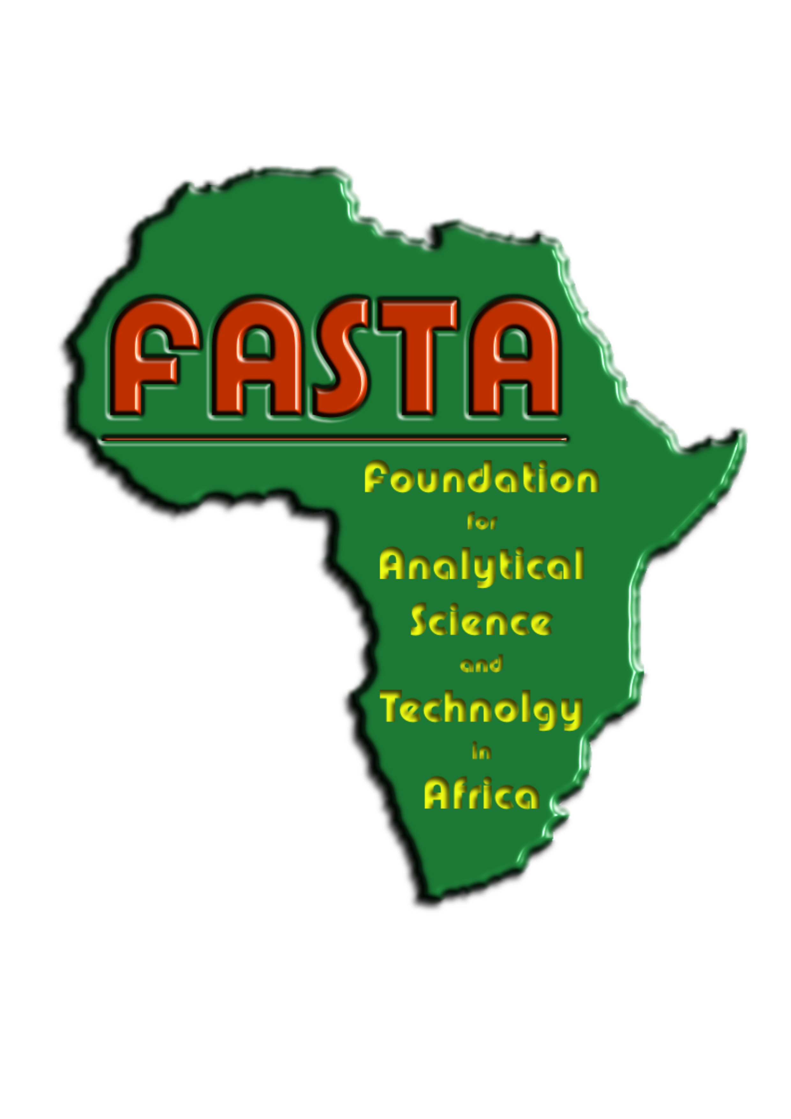 9 April 2008.

Who is FASTA?

FASTA is a registered charity comprised of scientists from the analytical sector in the UK. It was founded by Steve Lancaster and a group of colleagues from BP and Barrie Nixon from Mass Spec UK on September 20, 2006 to support scientific education and the preservation of the environment in Africa via capacity-building and technology transfer.

Advanced scientific technology, fundamental to the development and advancement of analytical chemistry, research and university teaching, is readily available in university laboratories throughout the developed world. Unfortunately, due to lack of funds, this technology is not readily available in most African countries. This dearth of scientific support and expertise is an impediment to economic advancement and to the development of scientific and environmental initiatives.

As scientists with a passion for chemistry and a dedication to the preservation of our environment, we have made an enduring commitment to provide participating laboratory facilities and collaborators with the tools they require to establish themselves and succeed. Several organisations, especially The British Mass Spectrometry Society, The Royal Society of Chemistry, Mass Spec UK and Perkin-Elmer, amongst others have been very supportive by providing generous grants and lots of moral support for us and this was instrumental in allowing us to set up the first GC-MS facility at Jomo Kenyatta University of Agriculture & Technology in Nairobi. To this end, we purchase and install laboratory equipment and offer training, ongoing maintenance, and technical and professional support. Our underlying aims are to:

- facilitate research and teaching into chemical systems and processes;

- facilitate research and teaching of environmental processes;

- enable / facilitate the provision of environmental monitoring services at the local and national level;

- promote and encourage food analysis in order to facilitate the import and export of foodstuffs.

What we have accomplished

Over the last two years our directors have raised more than £30,000 which we have used to install and maintain a GC-MS in the Chemistry Department at Jomo Kenyatta University of Agriculture & Technology (JKUAT) in Nairobi. It is currently being used for post graduate research and analysis of environmental samples at JKUAT. We have also introduced ATD equipment to be used with the GC-MS that will facilitate detailed atmospheric research and pollution monitoring. Through this work, the JKUAT is now recognised by the Kenyan government as a centre of excellence in environmental research. We are currently raising money to ship out a second MS system generously donated by Don Richards of Pfizer, and have a third in the pipeline which will be used specifically for our research into the conservation of vultures (see below).

Our collaborators

Determined to ensure the sustainability and success of this facility and its endeavours, FASTA scientists are collaborating with Professor Anthony Gachanja and continually widening the scope of the laboratory. Now that it has established itself as a centre for analytical excellence, we are pleased to help further develop the facility’s environmental monitoring and community outreach mandate.

We are now collaborating with Ms Ngaio Richards, a researcher and conservationist currently completing her doctoral work in the area of wildlife forensics. Ngaio is developing forensic methodology to detect veterinary drugs in livestock animals and vultures in Africa, following the mass mortality of vultures observed in India. She is also liaising with a number of collaborators in East Africa, including Wildlife Direct, the National Museums of Kenya and Maseno University on the broader and more immediate issue of human-wildlife conflict and wildlife (and human) poisoning in agricultural areas (see attached carbofuran Chemistry & Industry article).

FASTA and JKUAT will join forces with Ngaio and her collaborators as they:

- develop a strategic sampling network to monitor and record incidences of wildlife mortality (with emphasis on vultures, initially) throughout East Africa;

- provide workshops and training on fundamental and current analytical and forensics methodology to laboratory, field and research personnel within the network;

- offer community workshops to farmers, veterinarians and local agri-businesses on safe handling (for people and wildlife) and use of pesticides and other potentially dangerous compounds;

- encourage and support community endeavours to minimise human-wildlife conflict and reduce harmful impacts from pesticide use.

The outlook for 2008 is as follows:

Over the next 5 months, Ngaio will develop her detection methodology for a GC-MS which FASTA has purchased for the JKUAT laboratory. This GC-MS will be shipped to Nairobi in the coming months.

A pilot project will be set up with Professor Anthony Gachanja and the JKUAT laboratory to implement the detection methodology as part of specialised analysis of vulture samples, to be offered under the centre’s environmental analytical services. Ngaio’s detection methodology will also be adapted for analysis of equine doping so that the lab can offer low cost analysis of wildlife samples to conservation bodies and other stakeholders with minimal financial resources while meeting its own costs.

The JKUAT laboratory will liaise with laboratories and researchers within the network to remain apprised of developments in the conservation and analytical community.

FASTA is also now involved with the Royal Society of Chemistry’s initiative, The Pan Africa Chemistry Network (PACN), which will facilitate links between chemists across the entire African continent and facilitate collaboration with UK scientists. Both Steve and Anthony will attend the African Launch of PACN later in May.

Steve Lancaster
Ngaio Richards

